Core Stability

Transversus Abdominus is the main muscle involved in core stability. It is the deepest of all the abdominal muscles and wraps around the abdomen from the spine to the stomach thereby acting as the body’s natural corset or weight belt. If this muscle is active it will provide good stabilising support to the spine. It is important to train this muscle so that it becomes automatically active in everyday activities.

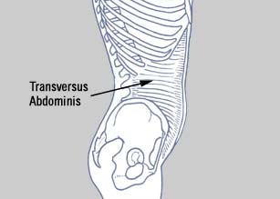

This muscle is trained in a different way to conventional muscle strengthening. It is not necessary to build it up it to maximum strength or bulk, it is more important to hold and sustain a gentle controlled contraction.

Initially core stability exercises are very basic and it is important to develop an awareness of how to switch them on to keep your low spine and pelvis in neutral while you move your limbs. Once you have mastered the basics it is easy to devise any exercise. Adopt a position, recruit the core muscles and then move another part of your body in a slow and controlled manner.

People with low back pain frequently demonstrate abnormal functioning of the core stabilising muscles. Therefore by addressing this dysfunction the intensity or frequency of future episodes of low back pain can be lessened and perhaps avoided. These exercises require many precise repetitions to reeducate one muscle so that it becomes automatically incorporated into functional movements.

Core Stability

Core contraction 1

- Lie on you back with knees bent, feet flat on the floor and shoulder width apart
- Pelvis in neutral
- Relax stomach muscles
- Place hands on pelvis and press fingertips deeply in and below the bony protuberances (this will enable you to feel the muscle contract).
- Draw your navel down to the floor as if you are trying to zip up a tight pair of jeans
- This contraction can be assisted by pulling up and in with your pelvic floor muscles
- Remember to breathe naturally throughout

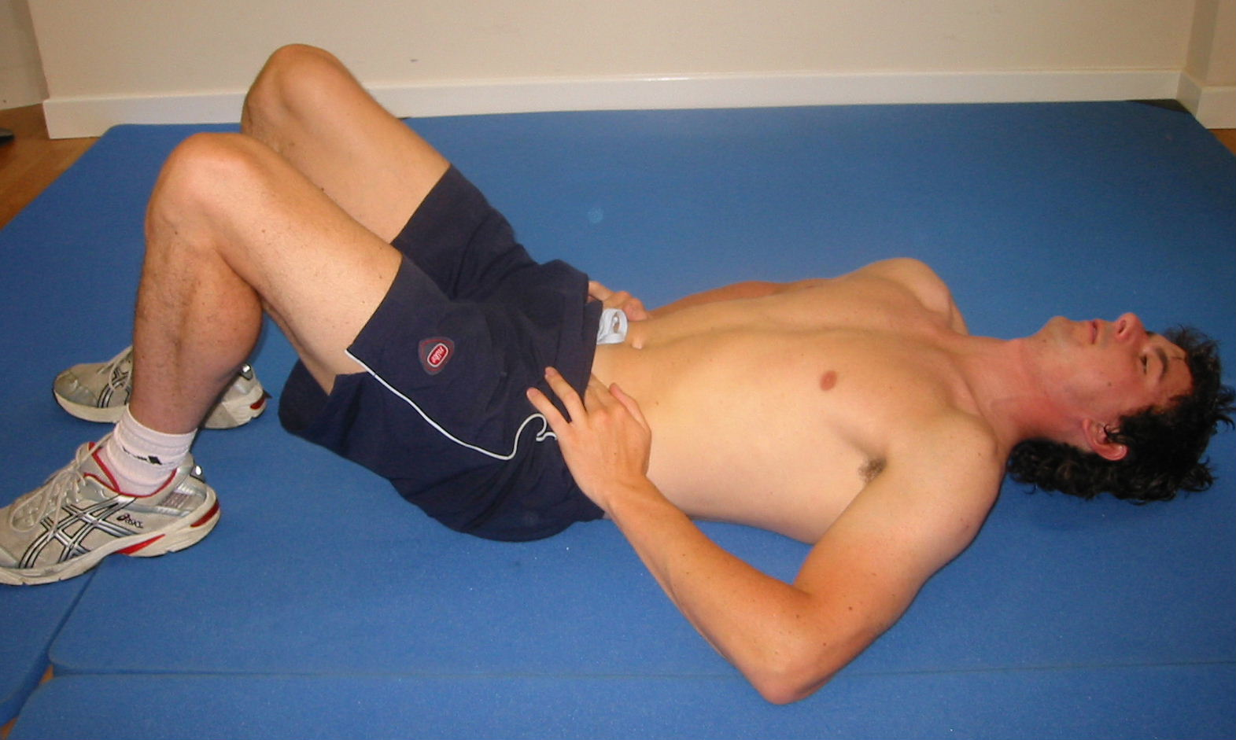

Hold ________ secs Reps _________ Sets __________
Progressive Leg Control Exercises

- Assume the position of core contraction 1
- Switch core muscles on
- Aim to maintain a still and steady pelvis throughout these exercises
- Remember to breathe throughout

1. Bent Leg Lift

- Maintaining the bend in the knee slowly raise and lower the leg

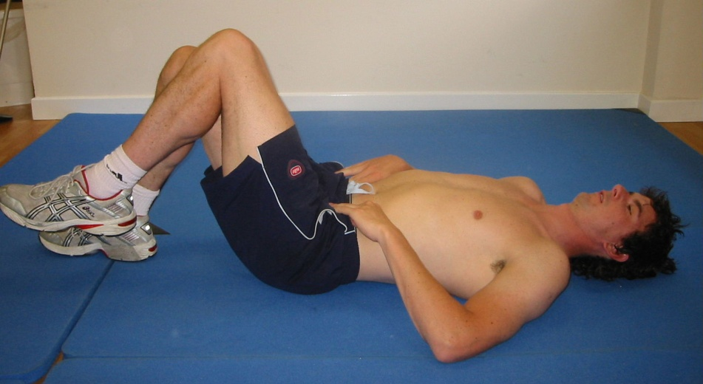

2. Straight Leg Lift

- Slowly lift your foot off the floor and straighten the leg before bending it back to the starting position

