**KNEE REHABILITATION**

### Initial

□ STATIC QUADS

Have the knee straight, tense up the front muscles of the thigh as if you are trying to straighten the knee and lift the heel.

LENGTH OF HOLD:

REPS: SETS:



□ INNER RANGE QUADS

Sit with your knee bent over a rolled up towel, high enough to be able to lift the heel off the ground.

Tighten up the knee muscles and lift your heel off the ground. Keep your knee firmly down on the roll.

Hold for a few seconds, trying to get the heel as high as you can, relax and repeat.

REPS: SETS:



□ STRAIGHT LEG RAISE

Keeping leg out straight tighten thigh muscles then lift heel about 6 inches off floor.

Hold for 3 seconds then lower. This does tend to be felt more round the hip than the knee.

REPS: SETS:



□ SINGLE LEG CO -CONTRACTION

Keeping core on push heel into floor and without actually moving your leg push down and back into the floor to activate the correct muscles.

LENGTH OF HOLD:

REPS: SETS:

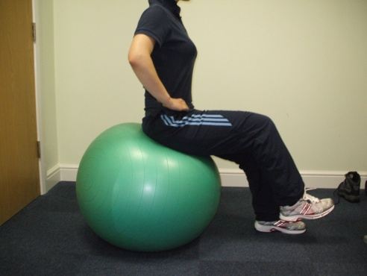

### Intermediate

□ SINGLE LEG STEP UP

Glutes and core engaged, drive through your heel (as shown) to step up. The key is not to push off your back leg.

Try to keep your knee in line with your toes and not let it drop inwards towards your other knee as your raise up onto the step

REPS: SETS:

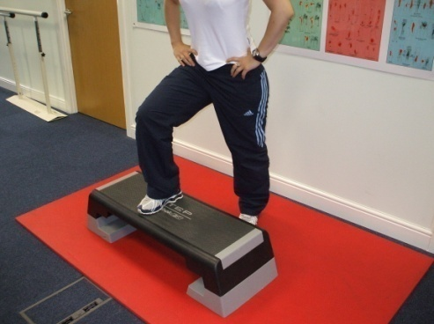

□ TERMINAL KNEE EXTENSION

Place band around back of knee. Allow a slight bend into the leg. Tighten gluts and quads as you squeeze your leg back to straight.

REPS: SETS:

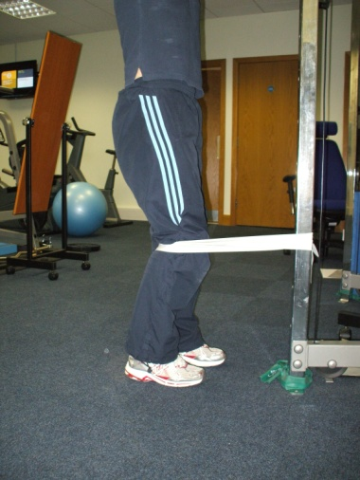

□ STRAIGHT LEG PRESS

The key is to control your knee as it straightens and not let is lock into extension

**DOUBLE** LEG WEIGHT:

REPS: SETS:

**SINGLE** LEG WEIGHT:

REPS: SETS:

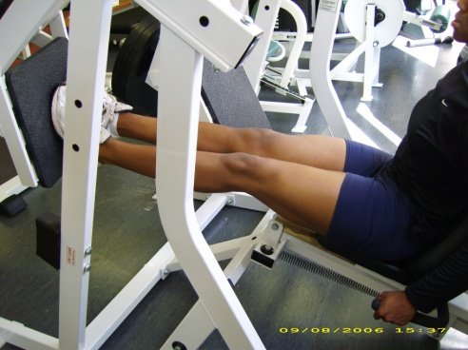

□ LEG EXTENSION

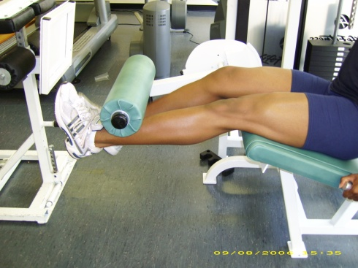

**DOUBLE** LEG WEIGHT:

REPS: SETS:

**SINGLE** LEG WEIGHT:

REPS: SETS:

□ SQUATS

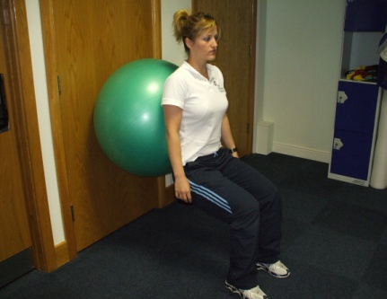 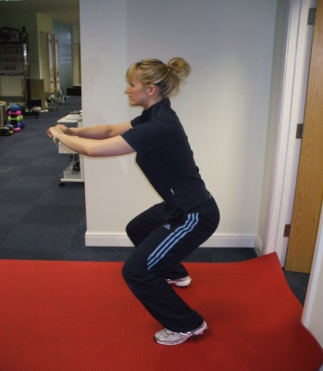 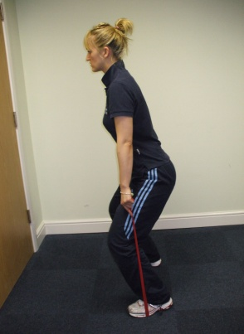

□ BALL SQUATS □ FREE SQUATS: □ BAND SQUATS:

REPS: SETS: REPS: SETS: REPS: SETS:

□ SINGLE LEG BALANCE WITH PULL IN

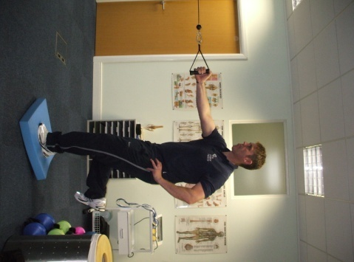

Stand on 1 leg. Pelvis neutral. Core + gluts activated. 60% of your weight should be through the back portion of your foot

Slight bend into knee. Hold this position as you pull in against weight with arm on opposite side.

REPS: SETS:

WEIGHT:

□ BALL MINISQUAT GLUTEAL FOCUS

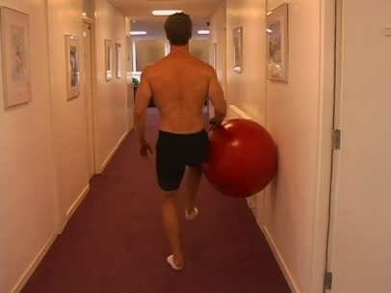

Standing on 1 leg, with 60% of your weight through the back portion of your foot. Pelvis neutral. Core + gluts activated. Lightly hold the gym ball against the wall with your opposite leg

Slowly squat down on one leg, keeping your knee in line with your hip and ankle. The movement is vertical.

REPS: SETS:

REPETITIONS:

SETS:

□ SPLIT LEG LUNGE

[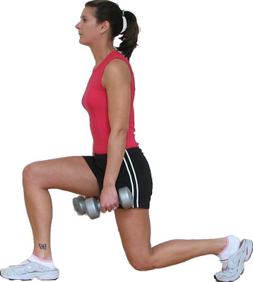](http://z.about.com/d/exercise/1/0/j/j/lunge.jpg)

Your front leg is the main weight bearing limb, with 60% of your weight through the back portion of your foot. Pelvis neutral. Core + gluts activated.

Lunge down controlling the alignment of your leg. The movement is vertical so be careful not to lean your knee **over** your toes.

REPS: SETS:

REPETITIONS:

SETS:

□ SPLIT LEG LUNGE WITH BAND

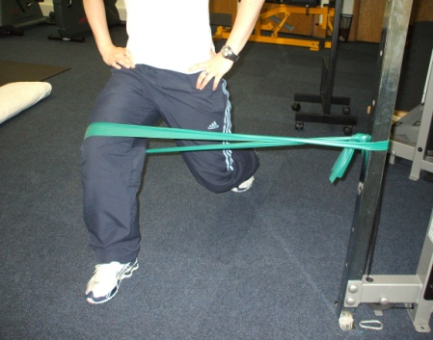

This is a progression of the exercise above. The Band is placed above the knee and around the outside of the thigh.

The key is to use your gluts to hold your knee out against the band to maintain alignment with hip and ankle.

REPS: SETS:

### Advanced

□ SINGLE LEG DIP / ECCENTRIC CONTROL

[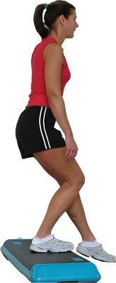](http://z.about.com/d/exercise/1/0/a/9/stepsquat.jpg)

Standing on 1 leg, with 60% of your weight through the back portion of your foot. Pelvis neutral. Core + gluts activated.

Slowly imagine lowering your opposite foot to the floor. The movement is vertical and it is very important not to let your knee move inwards or let your pelvis drop. Movement pattern is key.

REPS: SETS:

**CARDIOVASCULAR TRAINING:**

**BIKE**: PROGRAMME: RESISTANCE: TIME:

**X** **TRAINER**: PROGRAMME: RESISTANCE: TIME:

**TREADMILL**: INCLINE: SPEED: TIME: