**HIP SURGERY AND REHABILITION**

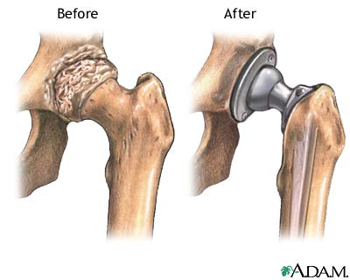

The hip joint has a wide range of movement and is subject to a range of disorders. Conditions that commonly lead to a hip joint replacement are osteoarthritis, rheumatoid arthritis, fracture of the neck of the femur (thigh bone), and damage resulting in loss of blood supply to the head of the femur (avascular necrosis).

**HIP REPLACEMENT SURGERY**

Hip replacement surgery provides a long term solution for worn or damaged hip joints which can cause severe pain and loss of mobility. The operation replaces both the natural socket (the acetabulum) and the rounded ball at the head of the thigh-bone (the femoral head) with artificial parts (prosthetics as seen below). These parts replicate the natural motion of the hip joint. It provides a long-term solution for worn or damaged hip joints caused by injury or disease, such as osteoarthritis, which can cause severe pain and loss of mobility

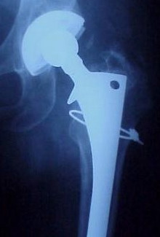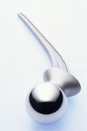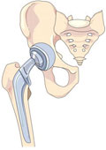

**HIP RESURFACING**

Total hip replacement surgery is usually very successful, but it can be invasive and require a lengthy recovery period. An alternative method, known as metal on metal (MoM) hip resurfacing, involves replacing the diseased, or damaged, surfaces in the hip joint with metal plating, which requires less prosthetics and less bone removal.

Hip resurfacing should be considered for people with advanced hip disease. Resurfacing is likely to last longer than a conventional replacement joint, which may start to wear after 10-20 years.

*All types of hip replacement surgery are extremely beneficial, offering an end to joint pain, increased mobility and a better quality of life.*

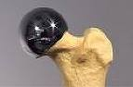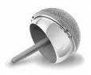

**REHABILITATION**

One of the critical success factors for a positive outcome is following the physical rehabilitation process. In order to help achieve the goals for a successful hip procedure, you must actively participate in the rehab process and work diligently on your own, as well as with the physical therapists, to achieve optimal results.

**DAY 1 – 7**

1. You will be guided by your therapist at the hospital to teach you basic exercises to begin strength work around the hip i.e. glut, quad squeezes and ankle pumps. Additionally you will be taught safe transfers from bed to chair etc, how to use walking aids and how to go up and down stairs.
2. Once your stitches have been removed and you are safely discharged from hospital it is now appropriate for you to begin outpatient physiotherapy.
3. At this stage it is also important that your pain levels are under control. This should be discussed with your consultant and hospital staff before you go home. Ensure that you keep yourself comfortable **you will gain nothing by coming straight off pain killers**. Recovery will also be easier whilst you are comfortable.

**2 WEEKS – 1 MONTH**

Aims:

1. Improve ROM
2. Increase Muscle strength
3. Gait re-education
4. Increase exercise tolerance

**Early Post Operative Exercises**

**ANKLE PUMPS & ROTATIONS**

Either in sitting or in lying, regularly pump ankles up and down. This is important to assist incirculation and reducing swelling in the lower limbs. Repeat in circular movements.

REPS: SETS:

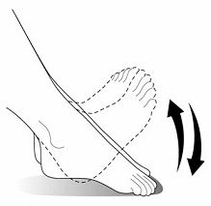

**STATIC QUADS**

Have the knee straight, tense up the front muscles of the thigh as if you are trying to

straighten the knee and lift the heel.

LENGTH OF HOLD:

REPS: SETS:



**INNER RANGE QUADS**

Sit with your knee bent over a rolled up towel, high enough to be able to lift the heel off the ground. Tighten up the knee muscles and lift your heel off the ground. Keep your knee firmly down on the roll.Hold for a few seconds, trying to get the heel as high as you can, relax and repeat.

REPS: SETS:



**ISOMETRIC GLUTEAL (BUTTOCKS)**

You can do this exercise lying on your back or while standing, holding onto your walker

Squeeze the cheeks of your buttocks together as tightly as you can

Hold for a count of 5-10 seconds.

REPS: SETS:



**STRAIGHT LEG RAISE**

Tighten the quadriceps muscles of your straight leg and lift the leg 12 in. (32 cm) to 18 in. (46 cm) off the floor, hold it for 5 seconds, then slowly lower the leg back down and rest a few seconds. This does tend to be felt more round the hip than the knee.

REPS: SETS:

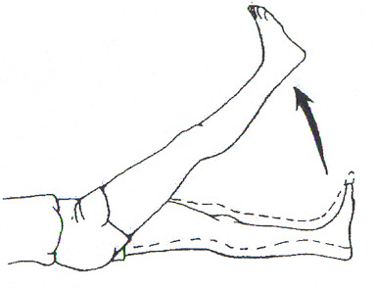

**STATIC MARCH**

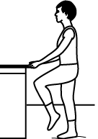

In standing, engage your core and gluteal muscles.

Slowly lift your knee and bend at your hip, as if to march on the spot. Only work within the range you are comfortable.

REPS: SETS:

|  |
| --- |
| **HIP EXTENSION**  Face the door. Using your operated leg, tighten your thigh and gluteal muscles and pull your leg straight backward. Return to the starting position.  REPS: SETS:  Progress to using Thera-Band around the ankle to increase resistance.  **HIP ABDUCTION**  Stand sideways to the door, with your operated leg away from the door. Tighten your thigh muscles, and extend your leg out to the side. Return to the starting position.  REPS: SETS:  Progress to using Thera-Band around the ankle to increase resistance. |

**4 – 6 WEEKS POST-OP**

1. Proprioception
2. Core stability
3. Functional movement patterns

BASIC TA/CORE CONTTRACTION

Assume picture shown.

Find your neutral pelvis by flattening your back into the floor so you could slide your hand underneath the curve in your back.

Find the bony protuberances on your pelvis. Walk your fingers in an inch and down an inch. Press your fingers into your stomach to feel your transverse abdominus (core muscle).

Draw your navel down to your spine, keeping pelvis in neutral. Remember to breathe naturally throughout.

REPS: SETS:

LENGTH OF HOLD:

Once you feel confident you can activate this muscle. Repeat cycle and slowly lift one leg off the floor a few inches whilst feeling your core is engaged.

REPS: SETS:

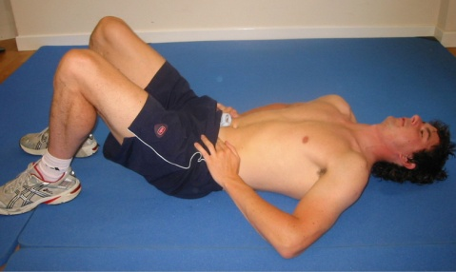

TA WITH HIP FLEXION

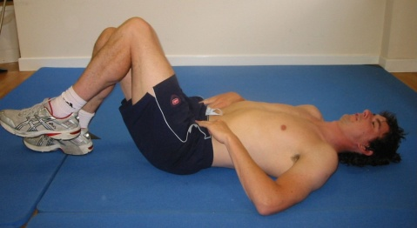

SEATED CONTROL WITH HIP FLEXION

Keeping core on push heel into floor and without actually moving your leg push down and back into the floor to activate the correct muscles.

REPS: SETS:

LENGTH OF HOLD:

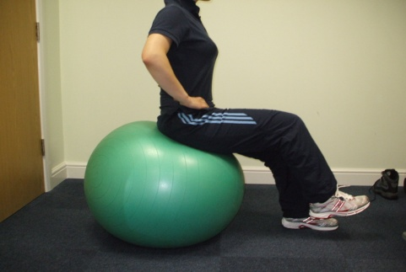

BRIDGING / GLUTS / HIP EXTENSION

Keeping core on and pushing your back into the floor to activate the correct muscles, curl your pelvis up into a bridge. Hold your gluts tight to support your pelvis.

REPS: SETS:

LENGTH OF HOLD:

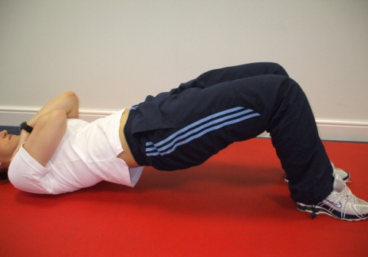

STEP UPS

Place your foot on the step. Engage your core and drive up through your front heel to step up onto the box. Do not push off your back leg. Try to keep your hip-knee-ankle in line and not to sway your trunk to the side as you drive up onto the step.

REPS: SETS:

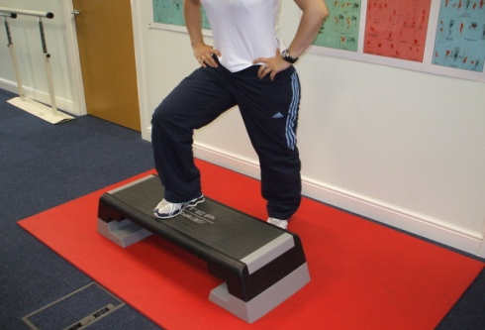

BALL SQUATS

Ball in small of back against the wall. Feet shoulder width apart. Squat to a comfortable level. Push up through heels keeping quads tight.

REPS: SETS:

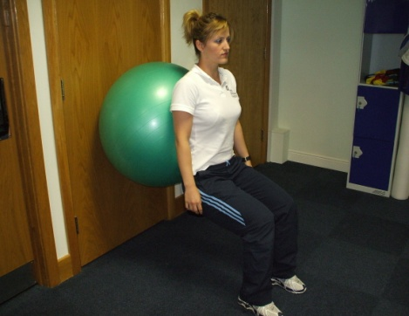

ISOMETRIC SKI HOLDS

This is an isometric strengthening exercise for the hip muscles and core stability. Bend knees to a comfortable level placing back flat against wall and hold a medicine ball away from the chest. Progress by increasing depth of the squat. Tension should be felt in quadriceps and not in the knee cap.

REPS: SETS:

LENGTH OF HOLD:

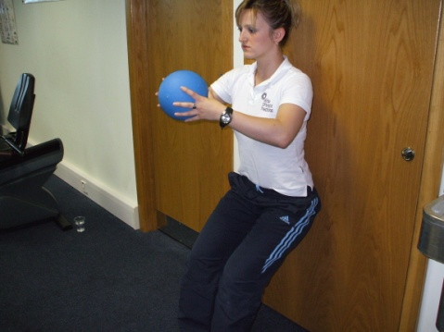

PRONE GLUT SETTING

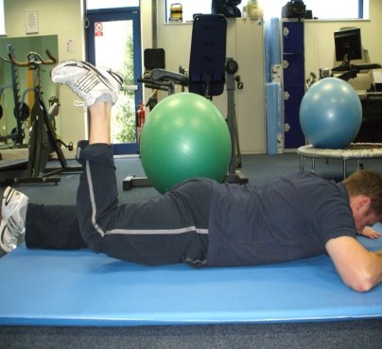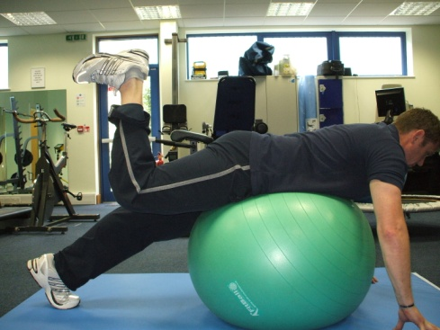

Lying on your front or on a gym ball with your arms to stabilise, engage your core and raise you leg (with your knee at 90 degrees) to activate your gluteal muscles. Keep your pelvis square to floor. REPS: SETS: LENGTH OF HOLD:

GLUT SETTING IN STANDING

Standing on one leg: keep 60% of your weight through the back portion of your foot, hip-knee-ankle should stay aligned, core activated and squeeze your gluts to hold your pelvis square. Slowly use your opposite hand to pull the pulley into your waistline. You will have to resist the gentle torsions that want to move your posture, but keeping your core and hip muscles engaged.

REPS: SETS: WEIGHT:

To progress this, repeat with balance cushion under your foot to challenge stability.

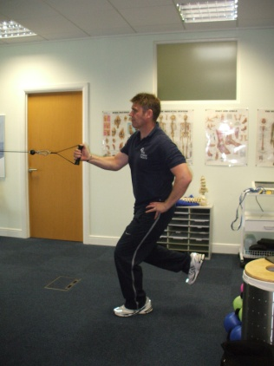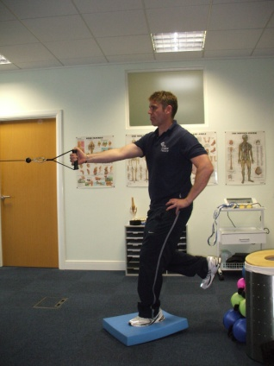

ACTIVE GLUT SETTING / MARCHING ON SPOT

Standing on one leg: keep 60% of your weight through the back portion of your foot, hip-knee-ankle should stay aligned, core activated and squeeze your gluts to hold your pelvis square (not letting it drop on one side). Progress this with using a trampet to challenge stability.

REPS: SETS:

