PLANTAR FASCIITIS

Anatomy
Plantar fasciitis is inflammation of the plantar fascia on the base of the foot. It is a painful overuse condition and generally both feet are affected. The plantar fascia is a thick band of connective tissue that runs from the heel bone (calcaneus) to the ball of the foot. This dense strip of tissue help support the arch of the foot by acting something like an archer’s bow.
The plantar fascia is made up of collagen fibers oriented in a lengthwise direction from toes to heel (or heel to toes). There are three separate parts: the medial component (closest to the big toe), the central component, and the lateral component (on the little toe side). The central portion is the largest and most prominent.
Both the plantar fascia and the Achilles' tendon attach to the calcaneus. The connections are separate in the adult foot. Although they function separately, there is an indirect relationship. If the toes are pulled back toward the face, the plantar fascia tightens up. This position is very painful for someone with plantar fasciitis.
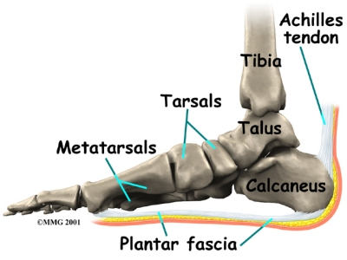

How does plantar fasciitis develop?
Plantar fasciitis can come from a number of underlying causes. Finding the precise reason for the heel pain is sometimes difficult.
As you can imagine, when the foot is on the ground a tremendous amount of force (the full weight of the body) is concentrated on the plantar fascia. This force stretches the plantar fascia as the arch of the foot tries to flatten from the weight of your body. This is just how the string on a bow is stretched by the force of the bow trying to straighten. This leads to stress on the plantar fascia where it attaches to the heel bone. Small tears of the fascia can result. These tears are normally repaired by the body.
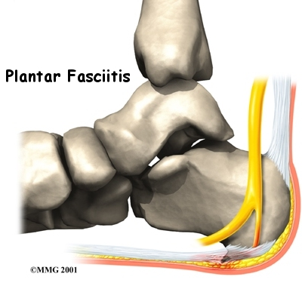
As this process of injury and repair repeats itself over and over again, a bone spur (a pointed outgrowth of the bone) sometimes forms as the body's response to try to firmly attach the fascia to the heelbone. This appears on an X-ray of the foot as a heel spur. Bone spurs occur along with plantar fasciitis but they are not the cause of the problem.
Symptoms
- Pain along the inside edge of the heel near the arch of the foot. The pain is worse when weight is placed on the foot.
- Usually most pronounced in the morning when the foot is first placed on the floor.
- Prolonged standing can also increase the painful symptoms.
- May feel better after activity but most patients report increased pain by the end of the day.
- Pressing on this part of the heel causes tenderness.
- Pulling the toes back toward the face can be very painful.

Treatment / Management
- Stretches for the calf muscles on the back of the lower leg to take the tension off the plantar fascia
- Supporting the arch with a well fitted orthotic may help take the pressure away from the plantar fascia
- Heel cups can add cushioning to reduce pain
- Physiotherapy treatment includes – soft-tissue massage, ultrasound, strengthening exercises, plantar fascia stretches and self management is taught – use of golf ball or ice bottle under foot for self massage
- Anti-inflammatory drugs may decrease inflammation in the acute stage to reduce pain
- Cortisone injections into the affected area of the fascia is also used to reduce pain and inflammation

CALF STRETCHES
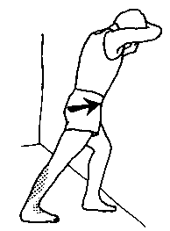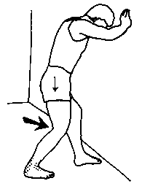
HOLD:
REPETITIONS:
SETS:

PLANTAR FASCIA STRETCHES

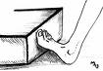
HOLD:
REPETITIONS:
SETS:

