LATERAL EPICONDYLITIS PAIN (TENNIS ELBOW) & REHABILITATION

WHAT IS TENNIS ELBOW?
An injury to the muscles and tendons on the outside of the elbow. It results from overuse or repetitive stress. The narrowing of the muscle bellies of the forearm as they merge into form tendons creates focused pressure where they insert into the tendon. In turn a small tear in some of the tendon fibres can occur which can result in larger tears. The body attempts to settle this but as repetitive stress is applied there is disarray in the lay down of the collagen fibres that compile the tendon. Inflammation will be present in acute episodes but usually the pain is due to ‘neovascularization’ (development of nerve endings and blood vessels into the tendon which are not normally there). The nerve endings create the pain you feel.
CAUSE?
The muscles that are involved in wrist extension all insert into the outside of your elbow (lateral epicondyle). It is an overuse or repetitive use of these muscles which creates the problem, particularly extensor carpi radialis brevis. Repetitive actions such as wringing clothes, use of hand held tools e.g. screwdrivers all create a heavy strain on this area. In sport i.e. tennis the problem can result from 1 of 3 possible causes:
(1) A one-handed backhand with poor technique (the ball is hit with the front of the shoulder up and power generated from the forearm muscles),
(2) A late forehand swing preparation with resulting wrist snap to bring the racquet head perpendicular to the ball, or
(3) While serving, the ball is hit with full power and speed with wrist pronation (palm turned downward) and wrist snap which increases the stress on the already taught extensor tendons.
The problem is likely to occur if you have unfit forearm muscles and all of a sudden load the muscles excessively by playing lots of tennis on holiday or starting DIY at home. Some cases, however, it can happen for no reason.
SIGNS AND SYMPTOMS
GENERAL | SPECIFIC
- Difficulty holding onto, pinching, or gripping objects. Point tenderness at or near the insertion sites of the muscles of the lateral elbow | - Painful wrist extension
- Pain, stiffness, or insufficient elbow and hand movement. | - Painful radial deviation (movement towards little finger)
- Forearm muscle tightness/ insufficient forearm functional strength | - Localized tenderness over the tendon  insertion of the lateral epicondyle.

A chronic condition can occur if the condition is not cared for properly. For this reason, it must be stressed that the rehabilitation process should not be progressed until you experience little or no pain at the level you are performing. Regaining full strength and flexibility is critical before returning to your previous level of sports activity.

PHASE 1
Goals: decrease inflammation and pain, promote tissue healing, and reverse muscle atrophy. During the acute stage of your injury, whether the medial or lateral elbow is affected, follow the RICE principle:
Rest - Avoid further overuse not absence of activity. Maintain as high an activity level as possible but avoid aggravating activities. Absolute rest encourages muscle atrophy, deconditions tissue, and decreases blood supply to the area, all of which is detrimental to the healing process. Pain is the best guide to determine the appropriate type and level of activity.
Ice – As long as inflammation is present. This may mean throughout the entire rehabilitation process and return to sports. Ice decreases the inflammatory process slows local metabolism and helps relieve pain and muscle spasm.
Compress and Elevate if appropriate to assist venous return and minimize swelling.
PHASE 2
Goals: Improve flexibility, increase strength and endurance, increase functional activities and return to function.

STRETCHING
Gentle stretching exercises including wrist flexion, extension and rotation. The elbow should be extended and not flexed to increase the amount of stretch as required. These stretches should be held for 20-30 seconds and repeated 5-10 times, at least twice a day. Vigorous stretching should be avoided - do not stretch to the point of pain that reproduces your symptoms.
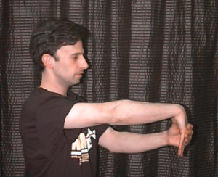

STRENGTHENING
With the elbow bent and the wrist supported perform the following exercises:
Wrist Extension. Place 1 kg. weight in hand (OR use theraband) with palm facing downward. Support forearm at the edge of a table or on your knee so that only your hand can move. Raise wrist/hand up slowly and lower slowly. As shown below:
REPETITIONS: SETS:
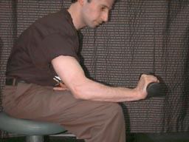
Forearm Pronation/Supination. Grasp hammer (wrench, or some similar device) in hand with forearm supported. Rotate hand to palm down position, return to start position (hammer perpendicular to floor), rotate to palm up position, repeat. To increase or decrease resistance, by moving your hand farther away or closer towards the head of the hammer.
REPETITIONS: SETS:
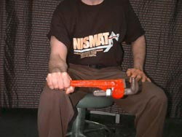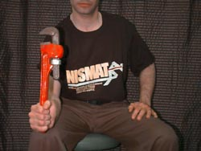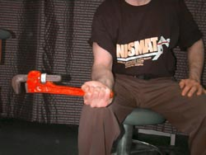

Finger Extension. Place a rubber band around all five finger tips. Spread fingers 25 times, repeat 3 times. If resistance is not enough, add a second rubber band or use a rubber band of greater thickness which will provide more resistance.
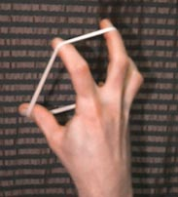
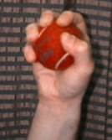
Ball Squeeze. Place rubber ball or tennis ball in palm of hand, squeeze 25 times, repeat 3 times. If pain is reproduced squeeze a folded sponge or piece of foam.

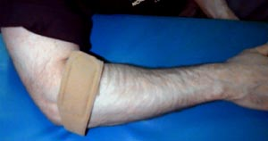
Bracing
Lateral counter-force bracing is believed to reduce the magnitude of muscle contraction which in turn reduces the degree of muscle tension in the region of muscular attachment. The counter-force brace is essentially an inelastic cuff that is worn around the proximal (near) forearm (against the forearm extensors for lateral epicondylitis.
In theory, the brace constrains full muscle expansion when the muscle contracts, diminishes muscle activity, and therefore the force generated by the muscle. An analogy is the fret on a guitar; when you exert pressure on a different fret along the neck of the guitar, it changes and reduces the tension on the guitar string above where the pressure is exerted.
The counter-force brace can be worn beginning in Phase 2 of your rehabilitation program. However, adhere to the following caution: do not become dependent on the counter-force brace and gradually wean yourself off its use as you start to return to sport. Counter-force bracing is a supplement to, not a replacement for your rehabilitation program.
Equipment Modifications
Using the wrong tennis racquet may have been a contributing factor to your injury. Guidelines for racquet selection for non-tournament players are provided below.
- Racquet material - Graphite composites are currently considered the best in terms of torsion and vibration control.
- Head size - A midsize racquet (95-110 square inches) is preferred. The popular oversized racquets cause problems because they make the arm susceptible to injury due to the increased torque effect of shots hit off-center.
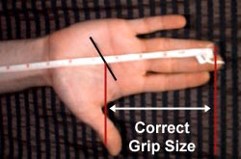
- String tension - stay at the lower end of the manufacturer's recommendation. While higher string tensions provide improved ball control, it also increases the torque and vibration experienced by the arm.
- Stringing material - synthetic nylon (re-string every 6 months).
- Grip size - A grip too large or too small lessens control and promotes excessive wrist movement. To measure an appropriate grip size for your hand (see image).

